1(A) 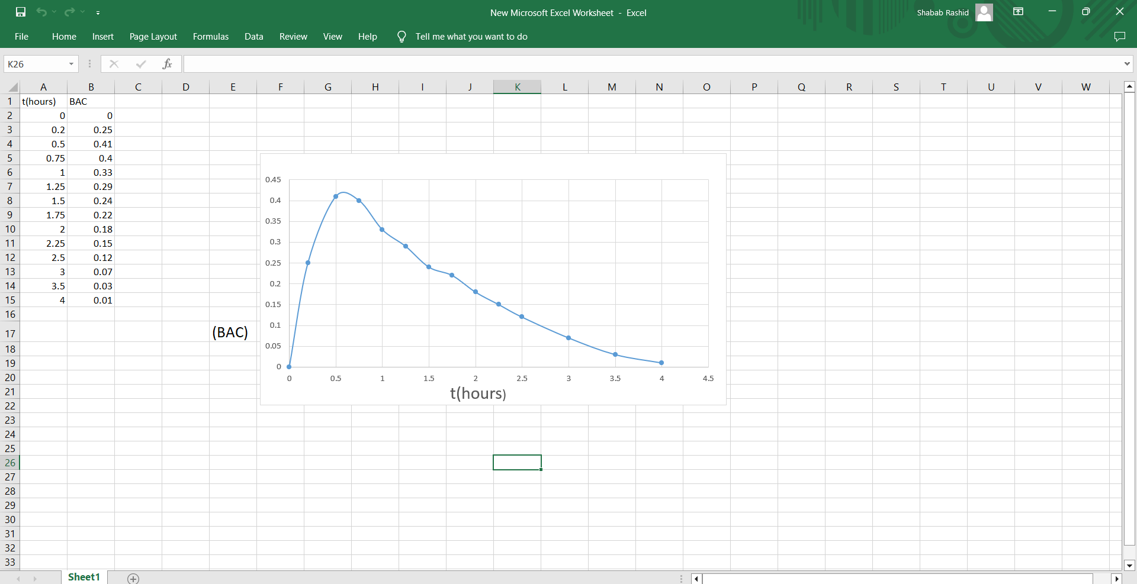

1(b): The BAC starts at 0 and increases rapidly, peaking at around 0.41 mg/mL at 0.5 hours. This indicates that the absorption of alcohol into the bloodstream occurs quickly after consumption. After reaching its maximum at 0.5 hours, the BAC begins to decline gradually. This suggests that the body starts metabolizing the alcohol relatively soon after it peaks. Between 0.5 hours and approximately 2 hours, the BAC decreases steadily from 0.41 mg/mL to about 0.15 mg/mL. This shows that the effects of alcohol diminish over this time period. After 2 hours, the decline continues more slowly, dropping to very low levels by 4 hours (0.01 mg/mL). This indicates that most of the alcohol has been metabolized and the effects are significantly reduced.

Overall, the data suggests that the acute effects of alcohol peak shortly after consumption and then decline gradually, with most of the alcohol eliminated from the bloodstream within a few hours.

2(a): (x2+(y−2)4=4

(y−2)4=4−x2

y−2=±(4−x2)1/4

y=2±(4−x2)1/4

y=2+(4−x2)1/4 (Since we want the top half of the circle, we take the positive root)

The expression for the function that represents the top half of the circle is:

y=2+(4−x2)1/4

2(B) 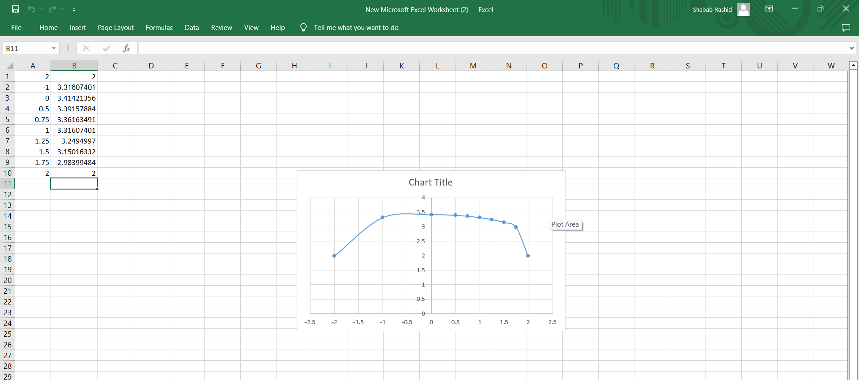

3(a)

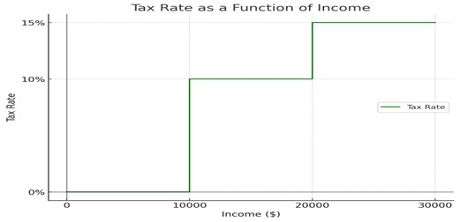

3(B) For an income of $14,000:

* The first $10,000 is exempt from tax.
* The remaining $4,000 is subject to a 10% tax rate.
  + Tax calculation: 0.1 × 4,000 = $400.

For an income of $26,000:

* The first $10,000 is exempt from tax.
* The next $10,000 is taxed at 10%.
  + Tax calculation: 0.1 × 10,000 = $1,000.
* The final $6,000 is taxed at 15%.
  + Tax calculation: 0.15 × 6,000 = $900.
* Total tax owed: $1,000 + $900 = $1,900.

3(C) 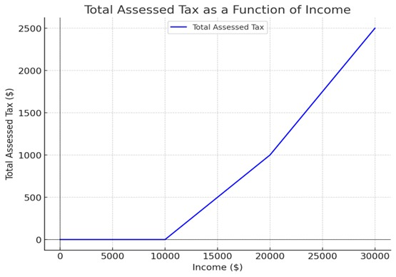

4.a) The graph shows exponential growth, which can be displayed by an exponential function of the form:

y=ae^bx

Here, the specific equation used is:

y=0.771e^0.79x

This equation shows the rapid increase observed in the plot. The high R^2 value of 0.988 indicates that the model is fit for the data, meaning it accurately represents how y grows quickly as x increases. As x gets larger, y grows at an accelerating rate, characteristic of exponential functions.

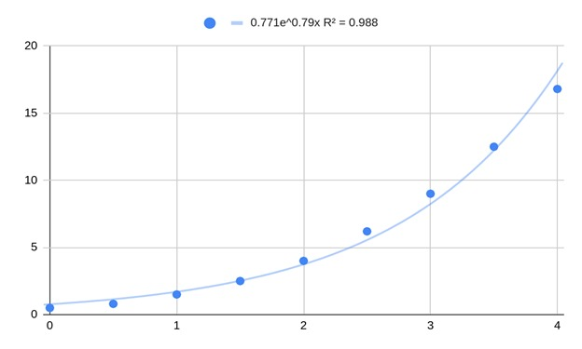

4.b) Decreasing Pattern:

There appears to be exponential decline on the graph. An exponential decay function often takes the following form:

y = 〖ae〗^(-bx)

This function is used when a quantity declines fast at initially and subsequently levels off, similar to the behavior seen in plot

This chart shows an exponential decay pattern with the equation 〖y = 16.9e〗^(-0.695x). The R^2 value of 0.992 suggests a very accurate fit and also it is capturing the sharp decrease in y as x increases.

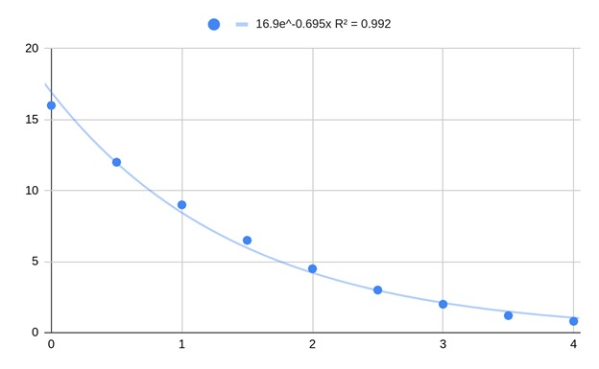

5.A) The scatter plot visualizes the relationship between femur length (cm) and height (cm) for eight male individuals. The X-axis represents the femur length, while the Y-axis represents the corresponding height.

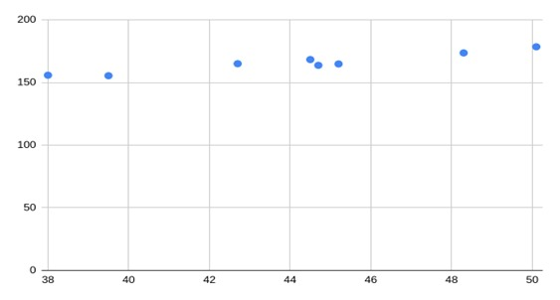

5.B) The scatter plot visualizes the relationship between femur length (cm) and height (cm) for eight male individuals. The fitted linear regression trendline, represented by the equation y=1.88x+82.6y = 1.88x + 82.6y=1.88x+82.6, indicates a positive correlation between femur length and height. The slope of 1.88 suggests that for every 1 cm increase in femur length, the height increases by approximately 1.88 cm.

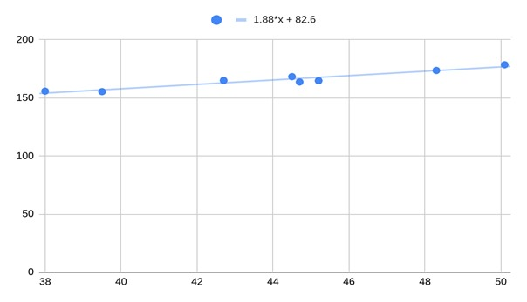

5.C) Using the linear regression equation obtained from Part B, y = 1.88x + 82.6, we can estimate the height of a person with a femur length of 53 cm.

Substitute x = 53 into the equation:

y = 1.88(53) + 82.6 = 99.64 + 82.6 = 182.24 cm

Therefore, the estimated height of a person with a femur length of 53 cm is 182.24 cm.

6a) 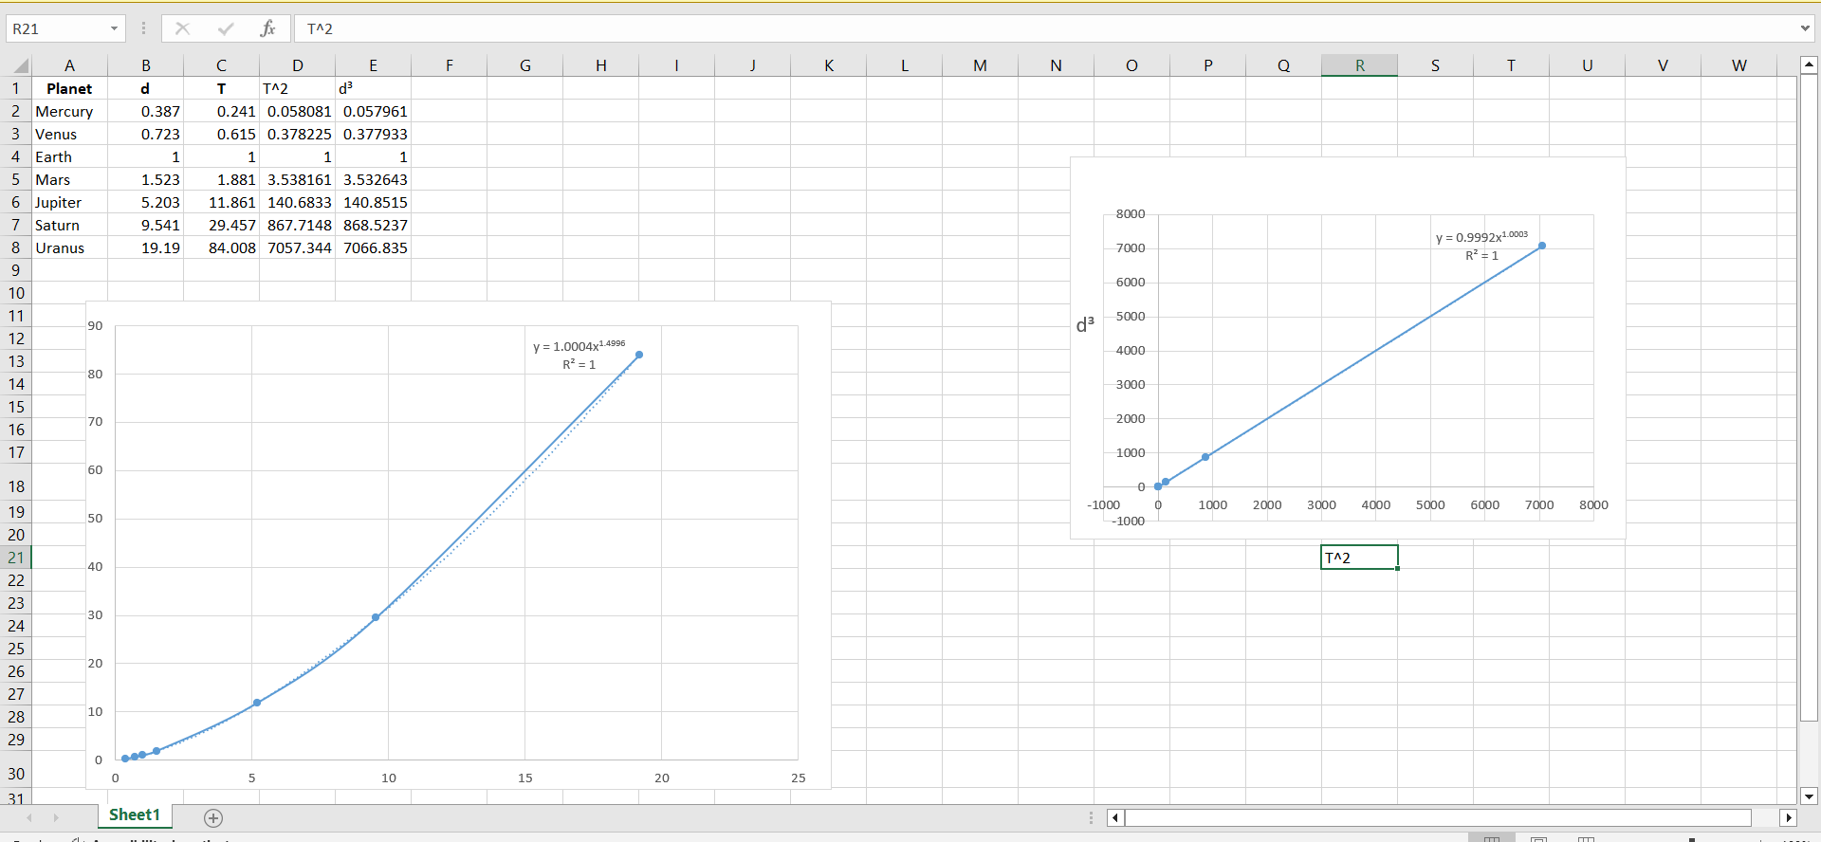

* 6(C) If the power model closely fits the data points in the original scatter plot (high R-squared value), it suggests that there is a polynomial relationship between distance and period. In the scatter plot of T² vs. d³, if the trendline shows a strong linear relationship (high R-squared), this would confirm that Kepler's Third Law holds true for the given data. By following these steps, you can effectively analyze the planetary data, fit a model, and validate Kepler’s Third Law through empirical evidence.

7) a) To clarify the relationship between the graph of y=fy = fy=f and f(x)f(x)f(x): when we refer to y=f(x)y = f(x)y=f(x), we are describing the relationship where the y-values are determined. by the corresponding x-values through the function fff. Essentially, the graph of y=f(x)y = f(x)y=f(x) represents the output of the function for each input.

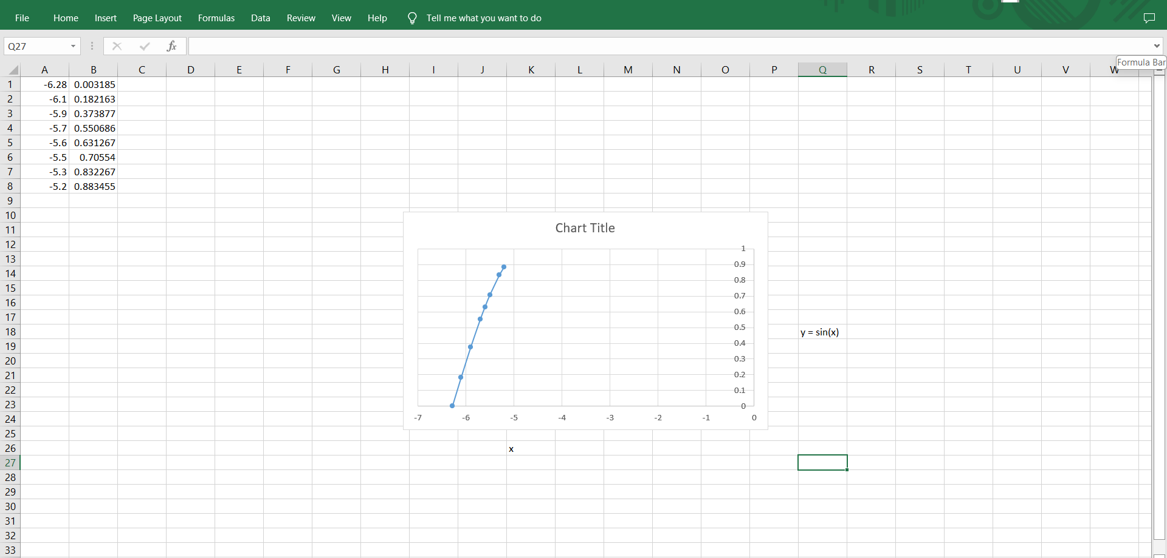

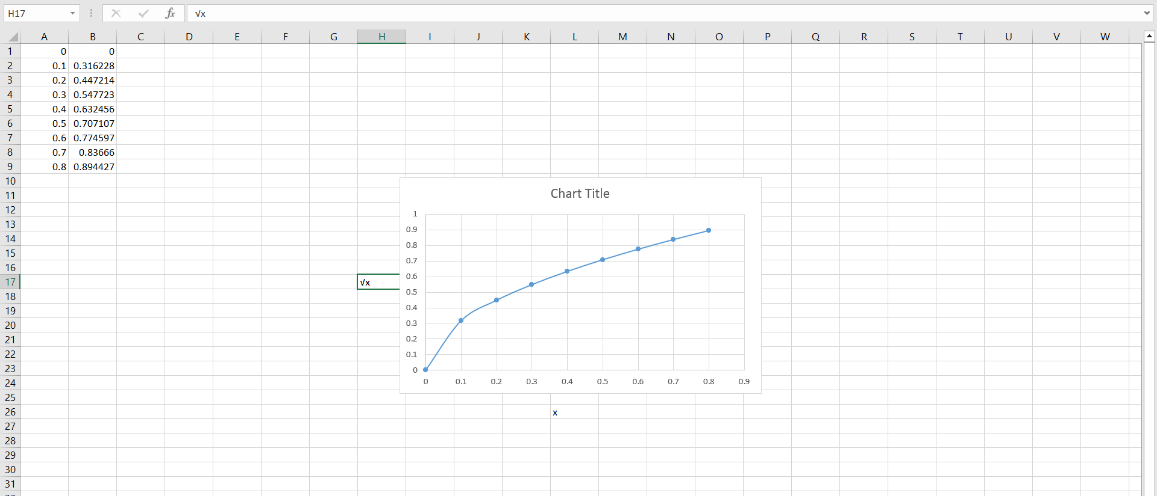

**8.Part (a): Evaluating (g∘f)(6)**

**Finding f(6)**: We look at the graph of the function f and find the value at x=6 . From the graph, we see that f(6)=6

1. **Finding g(f(6)**: Now we need to evaluate g(f(6), which is g(6). When we check the graph of g, we notice that g(6) is undefined. Since g(6) does not exist, it follows that g(f(6) is also undefined.
2. **Conclusion**: Therefore, (g∘f)(6) is undefined because we cannot find a value for g(6).

**Part (b): Evaluating (g∘g)(−2)**

1. **Finding g(−2)**: We start by looking at the graph of g and locating g(−2). The graph indicates that g(−2)=1.
2. **Finding g(g(−2)**: Next, we need to evaluate g(g(−2), which means we now find g(1). From the graph of g, we see that g(1)=4.
3. **Conclusion**: Therefore, (g∘g)(−2)=g(1)=4.

**Part (c): Evaluating (f∘f)(4)**

1. **Finding f(4)**: We look at the graph of f to find f(4). The graph shows that f(4)=2
2. **Finding f(f(4))**: We then need to evaluate f(f(4), which translates to f(2). Checking the graph again, we find that f(2)=−2.
3. **Conclusion**: Thus, (f∘f)(4)=f(2)=−2.